**Mcmeaty**

Design Brief

By

**Marc Greer**

GAME 115 Game Development Studio I

Professor Samoff

Fall 2021

**Abstract**

Mcmeaty has transported from his home to a dungeon Dr. Brock O. Lee. To get through the dungeon he must push giant blocks of his own kind. Angered by this he hunts the doctor down to get revenge.

**Genre**

2d Puzzle Adventure game

**Platform**

Gameboy Emulator

**Time Intervals**

Real-time

**Player Modes**

Single-player

**ESRB Rating**

T for Teens

**Primary Gameplay**

In Mcmeaty, the player plays as well Mcmeaty. Your goal is to solve puzzle by push blocks of meat onto pressure plates to unlock doors. There are two types of blocks a normal block that interacted with moves one space and the ice block keeps moving until it hits the wall.

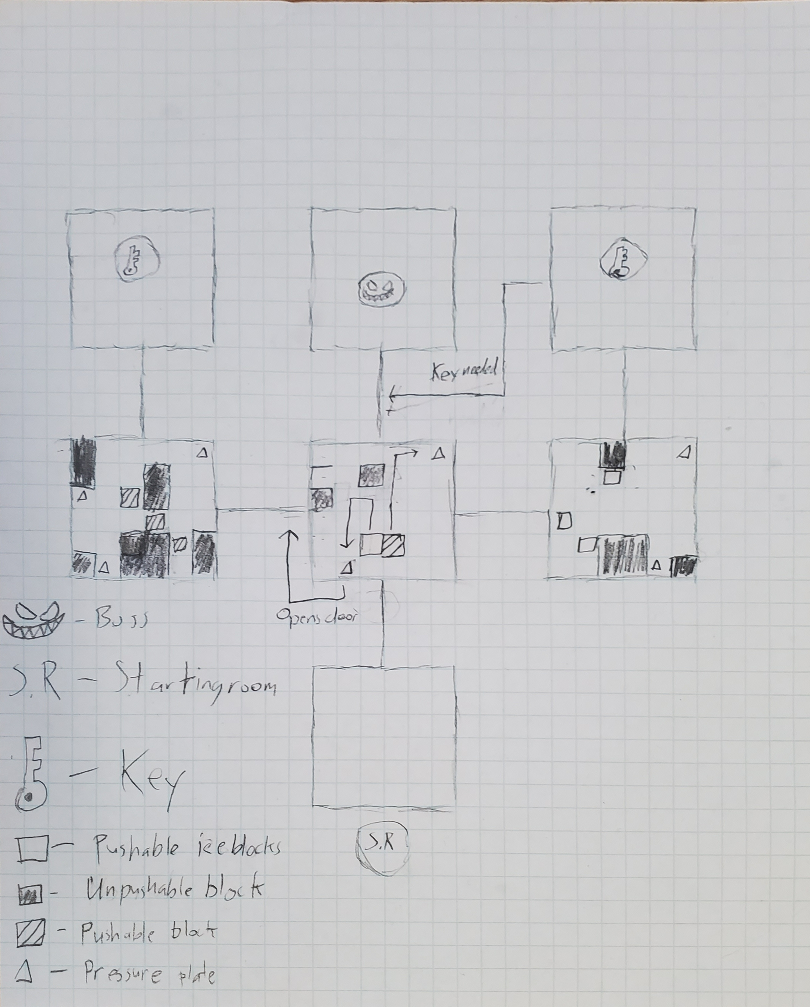

Top-down map

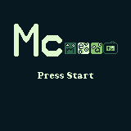

Title Screen

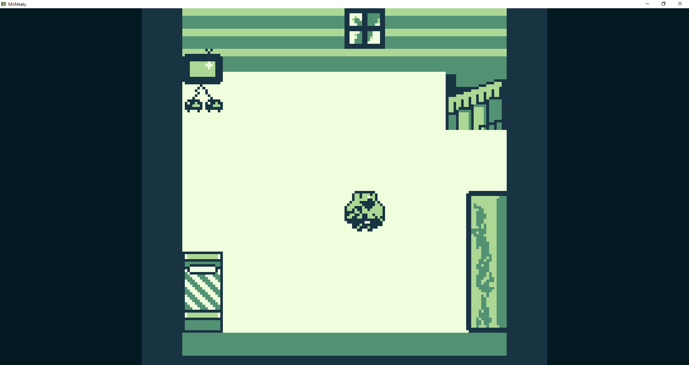

Starting Room

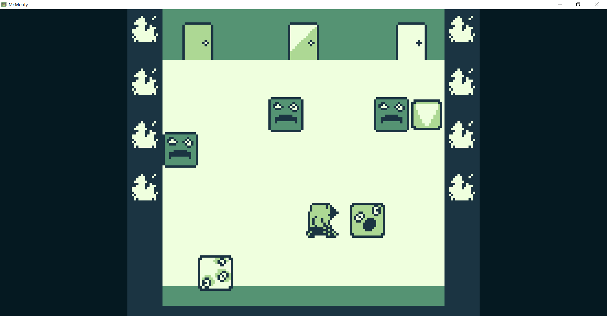

Tutorial room that teaches you how the different blocks work.

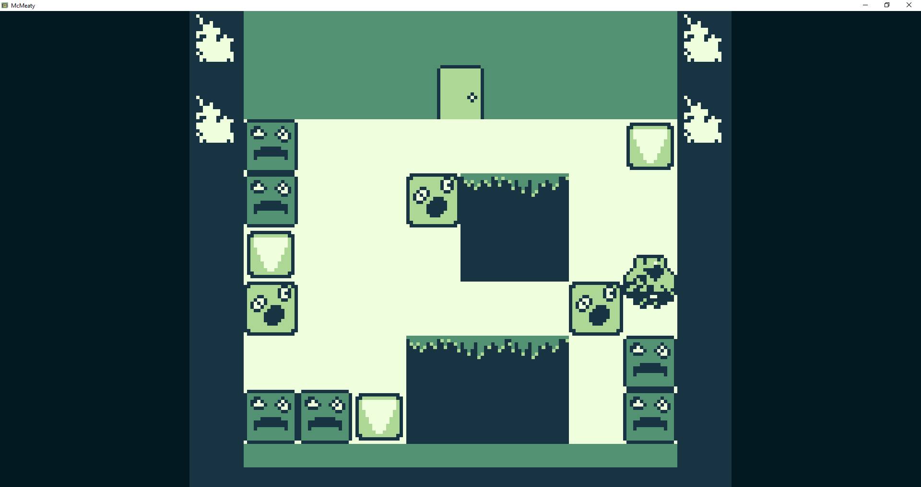

First Puzzle room focusing on normal blocks.